What is Change Control?
Change Control is the process that a company uses to document, identify and authorize changes to an IT environment. It reduces the chances of unauthorized alterations, disruption and errors in the system.

Why Change Control?
Whenever any new or different changes are requested for the system, especially by stakeholders, it is neither optional nor ignorable. It has to be implemented without affecting other components of the system. This is when the change control comes handy. It helps project teams to modify the scope of the project using specified controls and policies. Change Control is practiced whenever a project is not progressing as planned.
It is mandatory that a formal document for change request is completed and reviewed in order to keep control of change requests.
Number of question one might encounter while analyzing Change Control like
- Who will approve the change?
- Does it require to run through a change control board?
- How much time will be required to research and implement the change?
- What are the impacts of changes to other components of the system (schedules, cost, resources, etc.)?
- Is there any threshold under which the project management can approve it?

Different factors of Change Control process
There are various factors that a Change Control process should consider
Steps in Change Control Process | Action taken in Change Control
- Change request initiation and Control | - Request for changes should be standardized and subject to management review  - Change requestor should be kept informed
- Impact Assessment | - Make sure that all requests for change are assessed in a structured way for analyzing possible impacts
- Control and Documentation of Changes | - A change log should be maintained that tells the date, person details who made changes and changes implemented  - Only authorized individual should be able to make changes  - A process for rolling back to the previous version should be identified
- Documentation and Procedures | - Whenever system changes are implemented the procedures and associated document should update accordingly
- Authorized Maintenance | - System access right should be controlled to avert unauthorized access
- Testing and User signoff | - Software should be thoroughly tested
- Version Control | - Control should be placed on production source code to make sure that only the latest version is updated
- Emergency Changes | - A verbal authorization should be obtained, and the change should be documented as soon as possible

Process of Change Control
Before we look into what is involved in Change Control process, we will get familiarize with what documents are used in Change Control. While carrying out Change Control, there are mainly two documents involved
- Change Log: A change log is a document that list the details about all the Change Requests like project number, PCR (project change request) ID, priority, Owner details, Target date, status and status date, raised by, date when raised etc.
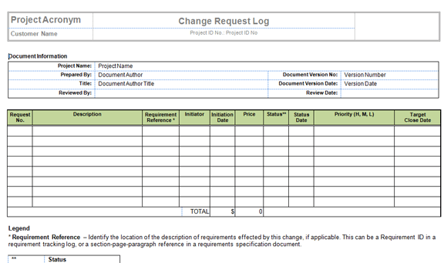
- Change Request Form: It is used to document details required to support the decision making process like type of change, benefits of change, name of resource requesting the change, time and estimate cost, priority of change, authorized person detail, change request status etc.
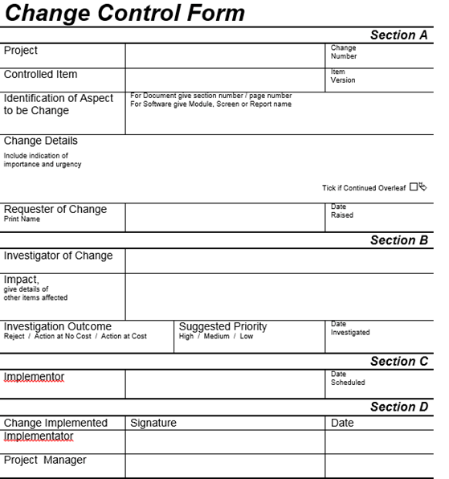

Change Process Flow-Diagram
Change Process follows a specific pattern to implement the changes in the product or system. Here through flow-diagram we explained what are the steps involved in the Change Process.
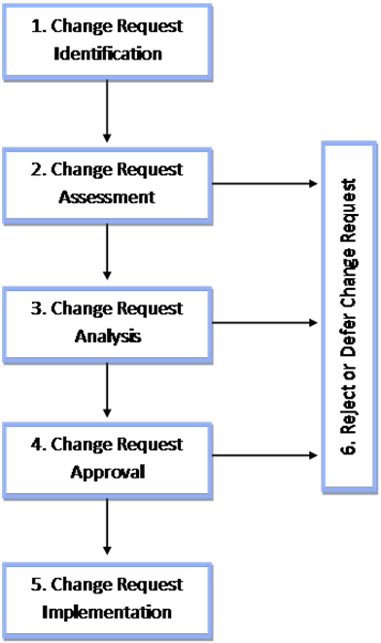

Steps for Change Control
Steps for Change Control | Action
- Change request identification | - Identify the need for a change and describe it on the project change request form
- Change request assessment | - If the change is not valid, it has to be deferred or rejected  - Determine appropriate resources required to analyze the change request  - Perform quick assessment of the potential impact and update the change request form  - At this stage, rejected change request should stopped
- Change request analysis | - For analysis assign the change request to an authorized member  - Deferred change re-enter this analysis step  - At this stage, rejected change request should stopped
- Change request approval | - Identify change risk and complexity level before approval  - Identify the impact level of the change before approval  - Review impact of Change Request to authorized person for approval  - At this stage, rejected change request should stopped
- Change request implementation | - Update project procedure and management plans  - Inform about the changes to the team  - Monitor progress of change request  - Record the completion of change request  - Close change request
NOTE: The approval for Change Control may be done by Project Manager, Lead IT or Lead Developer, Stakeholder.

Change Management Vs Change Control
Change Management | Change Control
It is responsible for managing and controlling change requests to effect changes to the IT infrastructure or any aspect of IT services to minimize the risk of disruption of services and promoting business benefit | Change control includes activities like submission, recording, analyzing and approval of change to improve the overall performance of the system or product

The configuration audit is an activity that is conducted to determine that a system or item meets it functional requirements and has been built in accordance with its blueprints, source code, or other technical documents. In plain English, audits are done to prove that (1) the thing works the way it should and (2) the builder's factory production system has reliable quality control, especially as it pertains to technical documentation (the documents that depict, describe, and define the thing).
The nature of the particular system or item determines the extent to which its hardware and software are reviewed for correlation with test results and design documentation. Generally, developed items are more thoroughly audited than “commercial off the shelf” (COTS) items. However, the bottom line of the audits is that they (1) validate that the system meets its functional requirements and (2) establish that the system’s technical documentation is accurate and well maintained. There are three basic categories of audits: functional, physical, and privately developed item.
Functional Configuration Audit (FCA):- The FCA is a review of a system's or item’s test, analysis, inspection, or demonstration records to validate that it meets its performance and interface/interoperability contract requirements. That is, the FCA verifies that the system's or item's required functional, physical, and interoperability characteristics meet the specified contractual requirements. A functional audit is a prerequisite to the performance of a physical audit.
Physical Configuration Audit (PCA):- A PCA involves the matching of a functionally successful "as built" system or item with its proposed product configuration identification (PCI), (the “PCI” is the set of documents that will eventually be used for production, acceptance, and modification management) Successful completion of a PCA will provide reasonable assurance that the PCI is (1) complete, (2) matches the system or item, and (3) is suitable for full-scale production, field operations, maintenance, and life-cycle modifications.
Privately Developed Item Audits:- Configuration audits on privately developed items, i.e., those not developed with Government funds, are usually either not audited or in some cases, a functional audit may be done to assure that its functional characteristics satisfy Government requirements. The audit is usually limited to an examination of test data provided by the contractor.
Why bother with these audits? The question is often asked why these audits should be done; i.e., what, if any, value do these audits bring to a system acquisition program? I have participated and been the lead for many audits and have found that they can be vitally important for the success of a system acquisition. These audits are often done before a system is actually shipped to the field for use. In some cases, these audits uncover safety hazards and other potentially serious problems that were heretofore unrecognized..
These audits are also extremely valuable in that they give a decision maker confidence that a program can proceed to full-scale production. That is, knowing that a system has been thoroughly audited and has been verified to perform as expected, and further knowing that all the vital technical documentation that will be used to build and sustain the system is accurate and is well maintained, provides the decision maker with confidence in granting permission to proceed with full-scale production and deployment of the system.
How to Prepare for an Audit. If an audit is a contract requirement, then you can usually follow these steps and be reasonably safe:
1) Check Section C of the contract to see which documents are binding on the CLINS to be audited. For example,
CLIN 0001, Radio PME: "Radio System Specification 0001C"
2) Check the SOW to verify the audit requirements.
3) Use Microsoft Excel or other spreadsheet applications to create a matrix which matches requirements with verification methods. For example: Audit Checklist.
4) Coordinate the audit details and logistics with the contractor (i.e., time, date, location, participants, scope, etc.)
5) Conduct the audit and document (For example Sample Audit Document & Audit Template) any deviations or problem areas.
6) Take follow-up action to resolve any deviations or problem areas.
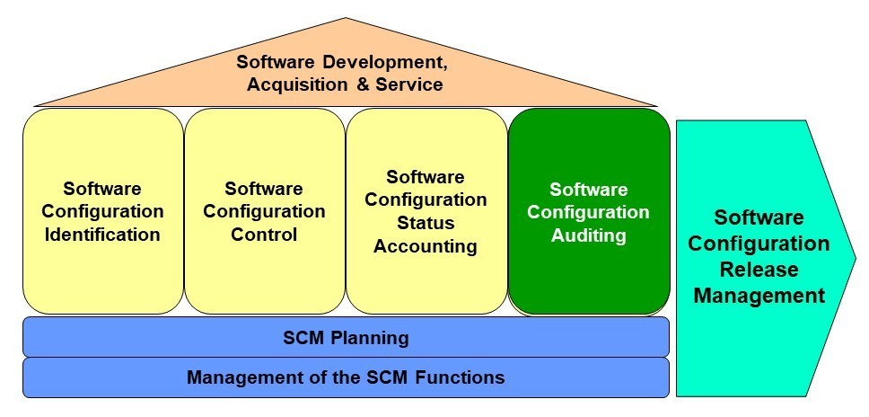

Software Configuration Management (SCM) Audits Part 1 – Introduction to SCM Audits
An audit is a planned and independent evaluation of one or more products, processes, projects, or systems to determine conformance or compliance to a set of agreed to requirements. Auditing is an “objective assurance and consulting activity designed to add value and improve an organization’s operations.” [Hutchins-03] Audits provide assurance by validating that the product, process, project and/or system are implemented in accordance with their requirements and objectives. Audits are management information activities because they provide ongoing analysis of the degree to which those implementations are effective and efficient, and they identify opportunities for continuous improvement. Audits also visibly demonstrate management’s support for the quality program.
In the case of Software Configuration Management (SCM) audits, three types of audits are typically performed:
- Functional Configuration Audit (FCA), which is an evaluation of the completed software products to determine their conformance, in terms of completeness, performance, and functional characteristics, to their requirements specification(s).
- Physical Configuration Audit (PCA), which is an evaluation of each configuration item to determine its conformance to the technical documentation that defines it.
- In-Process SCM Audits, which are ongoing evaluations conducted throughout the life cycle to provide management with information about compliance to SCM policies, plans, processes, and systems, and about the conformance of software products to their requirements and workmanship standards.
Parts 2 through 4 of this article will discuss the purpose of each of these three types of SCM audits. They will also provide examples of checklist items that could be used during audit evaluations and suggests evidence-gathering techniques for each item in those checklists.
When Are Configuration Audits Conducted
At a minimum, FCA and PCA should be conducted just before the final Ready to Beta Test or Ready to Ship review to provide input information into those reviews. In addition, these audits can also be conducted at other major milestones throughout the software development cycle as inputs into milestone reviews or other management oversite activities.
In traditional software development, as illustrated in Figure 1, the FCA and PCA activities should be conducted as part of creating the Product Baseline. Depending on the level of rigor, FCA and PCA activities could also be conducted at other major milestones (baselines), including:
- The Functional Baseline
- One or More Allocated Baselines
- One or More Development Baselines
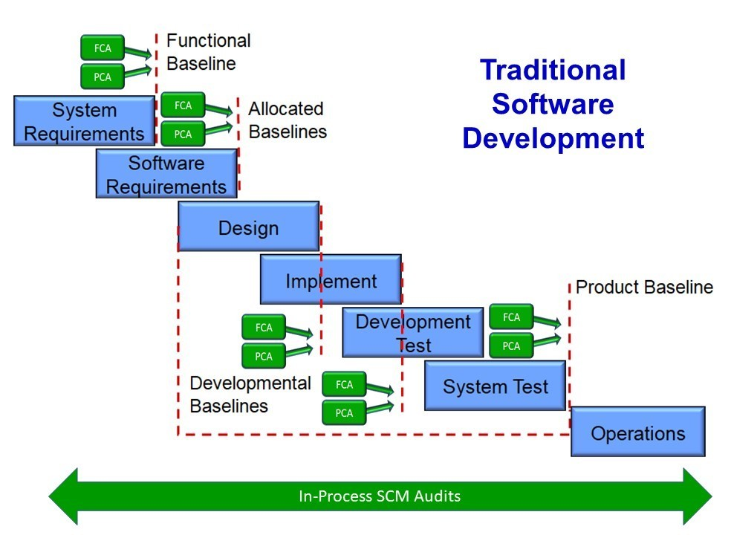
Figure 1: FCA and PCA Audits in Traditional Software Development
In agile software development, as illustrated in Figure 2, the FCA and PCA activities should be conducted as part of the software release milestone. Depending on the level of rigor, FCA and PCA activities could also be conducted at the end of each sprint (iteration).
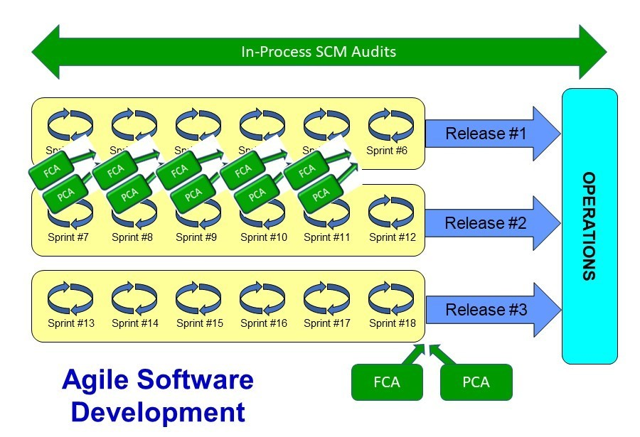
Figure 2: FCA and PCA Audits in Agile Software Development
In-process SCM audits can be conducted throughout development as needed. Plans for any in-process SCM audits should be specified in the Software Quality Assurance (SQA) plans.

